Name: __________________________
Wavelength, Amplitude and Frequency
- Which of the following waves has the largest wavelength?
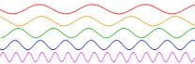

A.
- What determines the energy in a wave?
B.
- Which of the waves to the right carries the most energy?

C.
- Which of the waves to the right carries the least energy?

- Measure the wavelength of each wave:
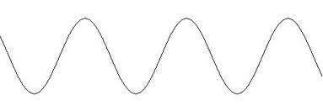

- Determine the frequency of each wave:

1
0
3
2
4
5
0
1
2
3
2
1
0

Name: ________________________
Frequency, Wavelength, Period and Wave Speed

Equations: v = λ*f f = 1/p p = 1/f

- The Sears Tower sways back and forth with a period of 0.10 seconds. What is its frequency of vibration?

- An ocean wave has a length of 10.0 m. A wave passes a fixed location every 2.0 s. What is the speed of the wave?

- Water waves in a shallow dish are 6.0 cm long. At one point, the water oscillates up and down at a rate of 4.8 oscillations per second.
  - What is the speed of the water waves?

  - What is the period of the water waves?

- Water waves in a lake travel 4.4 m in 1.8 seconds. Their period of oscillation is 1.2 s.
  - What is the speed of the water waves?

  - What is their wavelength?

- A group of swimmers is resting comfortably in the sun on an offshore raft. They estimate that 3.0 meters separates a trough and an adjacent crest of the surface waves. They count 14 crests that pass by the raft in 20 seconds. How fast are the waves moving?

- A sonar signal of frequency 1.00 x 10⁶ Hz has a wavelength of 1.50 mm in water.
  - What is the speed of the signal in water?

  - What is the period in water?

- A sound wave of wavelength 0.70 m and velocity 330 m/s produces waves with what frequency?

- If bats emit a chirp at 60.0 kHz (1 kHz = 1000 Hz) and the speed of sound in air is 340 m/s, what is the wavelength of that sound.

- The distance between two crests of a certain transverse wave is 1.20 m. Eight crests pass a given point every 12.0 seconds. Find the wave speed.

Name: _____________________________
Parts of a Wave

Write the name of each labeled part of the wave below:

D
G
F
H
B
C
E
A

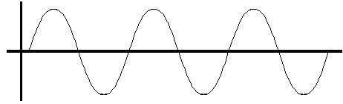

A = ______________________ E = ______________________

B = ______________________ F = ______________________

C = ______________________ G = ______________________

D = ______________________ H = ______________________

What type of wave is shown in the diagram above? ___________________________

Write the name of each labeled part of the wave below:
B

A

C

A = __________________________

B = __________________________

C = __________________________

What type of wave is shown in the diagram above? ___________________________

