NAME: __________________

PROJECTILE MOTION SIMULATION

OBJECTIVE: To use a computer simulation to investigate the variables involved in projectile motion.

PART 1 – HIT THE TARGET (Projectile Launched Horizontally)
- Go to: http://phet.colorado.edu/sims/projectile-motion/projectile-motion_en.html
- Select the pumpkin from the item list and set the angle to 0.
- Adjust the position of the cannon and target to match the picture below. Drag the circle located beneath the cannon to move the cannon up.
- Drag the yellow circle to the middle of the cannon platform. Then, drag the red crosshair horizontally to the position listed in the chart.
- Move target to the red crosshairs.
- Adjust the initial speed until the pumpkin hits the exact center of the target. SCORE will appear. Record this velocity in the chart below.
- Click the erase button to clear the screen. Repeat for other positions.
- Repeat steps 4-7 using the piano.
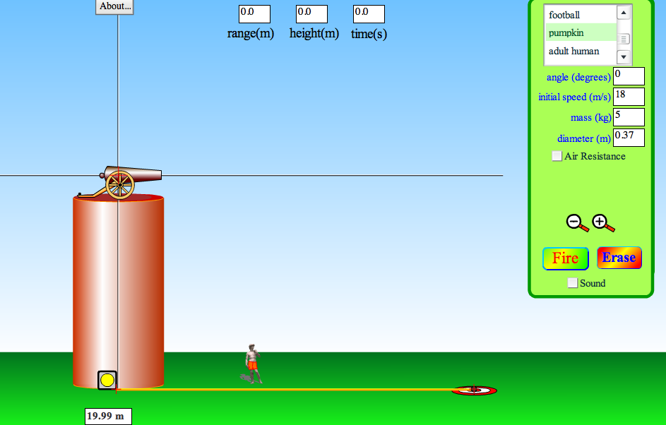

Pumpkin Launch Piano Launch
Position  (m) | Initial Speed to hit Target  (m/s) | Mass  (kg) | Diameter  (m)
20
40
Position  (m) | Initial Speed to hit Target  (m/s) | Mass  (kg) | Diameter  (m)
20
40

Analysis Questions:
- If the target were placed at a distance of 60 m:
  - What initial speed do you predict would be necessary to hit the target?

  - Try the speed hypothesized in part a. Did it work? Why or why not?
- What relationship is there between speed and position of target?
- Since the cannon launches the pumpkin horizontally, the initial speed of the object is (horizontal or vertical)?

- When the object was changed from the pumpkin to the piano, the mass and diameter changed.
Did either of these aspects affect the range?

- With the target at 40 m, launch the piano with air resistance using the same speed used to hit the target.
  - What do you predict will happen when the piano is launched?

  - Use the simulation to test your prediction. Is it confirmed?

PART 2 – DON’T HIT THE TARGET (Use the simulation from PART 1, no air resistance – fire any object you choose)
- Shoot the cannon at an initial speed of 10 m/s. Record the range, height and time in the table below.
- Increase the speed of the cannon by 10 m/s and shoot the cannon again. Record the range, height and time in the table.
- Increase the speed by 10 m/s for each additional trial.

Trial | Speed  (m/s) | Range  (m) | Height  (m) | Time  (s)
1 | 10
2 | 20
3 | 30
4 | 40
5 | 50
Analysis:
- What can you conclude about the range of the projectile in each trial? Why?

- What can you conclude about the height of the projectile in each trial? Why?

- What can you conclude about the time of the projectile in each trial? Why?

- Do an additional trial, this time setting the velocity at 1000 m/s.
  - How long do you think it will take to hit the ground?

  - From the simulation, what was the time for the object to hit the ground?

- Compare the time in Question 4 part b to Trial #5.
  - What do you notice about the time for each?

  - How is this possible?

PART 3 - INITIAL VELOCITY (Projectile Launched at an Angle)
- Refresh the website: http://phet.colorado.edu/sims/projectile-motion/projectile-motion_en.html
- Set the angle to 45° (make sure the cannon is at ground level as shown below)
- Set the Initial Speed to 10 m/s (this is the initial velocity)
- Click FIRE
- Use the yellow measuring tape to measure the maximum height of the projectile.
- Complete the data on the table.
- Continue to FIRE, changing only the initial velocity to those in the data table. Zoom out to collect data for the larger initial speeds.
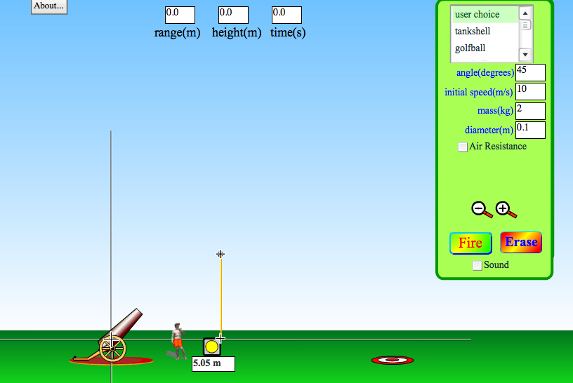
Initial Speed (m/s) | Angle  (°) | Mass  (kg) | Range  (m) | Maximum Height  (m) | Time  (s)
10
20
30
40
50

- Which variable(s) were affected by a change in the initial velocity?

- Which variable(s) were unaffected by a change in the initial velocity?

- What can you conclude about a projectile launched at an angle?

PART 4 - LAUNCH ANGLE (Use the simulation from part 3, no air resistance)
- Erase the previous trials from Part 3
- Set the Velocity to 50 m/s
- Set the angle to 10°
- Click FIRE
- Use the yellow measuring tape to measure the maximum height of the projectile.
- Complete the data on the table.
- Repeat the procedure for the different launch angles.
Initial Velocity (m/s) | Angle  (°) | Range  (m) | Maximum Height  (m) | Time  (s)
50 | 10
50 | 30
50 | 45
50 | 60
50 | 80

- Which angle had the maximum range?

- Which angle had the largest maximum height?

- a. Compare the maximum range obtained for these pairs of launch angles.
    - 10° and 80°

    - 30° and 60°

b. What pattern do you notice about these angles?

- A projectile is launched at an initial speed of 50 m/s with a horizontal angle of 76°. Use the simulation to answer these questions:
  - What is its range?

  - Give another angle that will produce the same range. Does the simulation verify your prediction?

  - What is the sum of the two angles that produce this range?

