Newton’s 3rd Law Questions

- Does a baseball bat slow down when it hits a ball?
- Why does a rope climber pull downward on the rope to move upward?
- Suppose two carts, one twice as massive as the other, fly apart when the compressed spring that joins them is released. How does the acceleration of the cart with mass 2m compare to the acceleration of the cart with mass m?
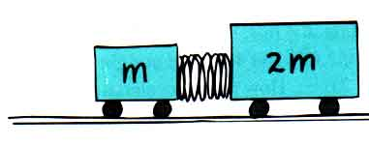
- If a Mack truck and Honda Civic have a head-on collision:
  - Upon which vehicle is the impact force greater?
  - Which vehicle experiences the greater acceleration?
- Consider a tug-of-war on a smooth floor between people wearing socks and people wearing rubber-soled shoes. Why do the people wearing rubber-soled shoes win?
- Two people of equal mass attempt a tug-of-war with a 12-m rope while standing on frictionless ice. When they pull on the rope, they each slide toward each other.
  - How do their accelerations compare?
  - How far does each person slide before they meet?

- Three blocks are in contact with each other on a frictionless horizontal surface. The masses of the blocks are m₁ = 1 kg , m₂ = 2 kg, m₃ = 3 kg. A horizontal force F = 24 N is applied on m₁.
m₃
m₂
m₁
F

  - Draw a free-body diagram for each object
  - Find the net force on each block.
  - Find magnitude of the contact forces between the blocks.

- Two masses, m₁ and m₂, situated on a frictionless, horizontal surface are connected by a massless string. A force, F, is exerted on one of the masses to the right.
m₂
m₁
F

  - Draw a free-body diagram for each object.
  - Determine the acceleration of the system, a, in terms of m_{1,} m_{2,} F and any other necessary constants.
  - Determine the tension, T, in the string in terms of m_{1,} m_{2,} F and any other necessary constants.
- Two blocks, joined by a string, have masses of M₁ = 6.0 kg and M₂ = 9.0 kg. They rest on a frictionless horizontal surface. A 2nd string, attached only to the 9-kg block, has horizontal force = 30 N applied to it. Both blocks accelerate.
  - Determine the acceleration of the blocks
  - Find the tension in the string between the blocks.
M₂
M₁
F = 30 N

- A 5.0 kg block is placed on top of a 10.0 kg block. A horizontal force of 45 N is applied to the 10.0 kg block, and the 5.0 kg block is tied to the wall. The coefficient of kinetic friction between the moving surfaces is 0.20.
5.0 kg
10.0 kg
F = 45 N

  - Draw a free-body diagram for each block.
  - Determine the tension in the string on the 5.0 kg block.
  - Determine the acceleration of the 10.0 kg block.

- Two blocks of mass m₁ = 5 kg and m₂ = 7 kg are placed in contact with each other on a frictionless horizontal surface. A horizontal force of 20 N is applied to the block of mass 7 kg.
m₂
m₁
F = 20 N

  - Determine the acceleration of the two-block system.
  - Determine the magnitude of the contact force between the blocks.

- A 75.0 kg man stands on a scale in an elevator. Starting from rest, the elevator ascends, attaining its maximum speed of 1.20 m/s in 1.00 s. It travels at a constant speed for the next 10.0 s. The elevator then undergoes a uniform acceleration in the negative y direction for 1.70 s until it comes to rest.
  - What does the scale register before the elevator starts to move?
  - What does the scale register during the first 1.00 s?
  - What does the scale register while the elevator is traveling at a constant speed?
  - What does the scale register during the time it is slowing down?

Answer Key:

- Does a baseball bat slow down when it hits a ball?

A: When the bat exerts a force on the baseball, the baseball also exerts a force on the bat in the opposite direction.

- Why does a rope climber pull downward on the rope to move upward?

A: As the climber pulls down on the rope, the rope pulls up on the climber. This is another good example of Newton's Third Law or the Law of Action and Reaction.

- Suppose two carts, one twice as massive as the other, fly apart when the compressed spring that joins them is released. How fast does the heavier cart roll compared to the lighter cart?
A: According to Newton's Third Law, the forces on these two masses must be equal (and in opposite directions). According to Newton's Second Law, F = m a, we find a = F / m. That means the acceleration of the twice-as-massive cart will be one-half the acceleration of the other.

- If a Mack truck and Honda Civic have a head-on collision, upon which vehicle is the impact force greater? Which vehicle experiences the greater acceleration?

A: The force will be the same on the two vehicles, according to Newton's Third Law. That means the Civic, with far less mass, will experience a much greater acceleration, according to Newton's Second Law.

- Consider a tug-of-war on a smooth floor between people wearing socks and people wearing rubber-soled shoes. Why do the people wearing rubber-soled shoes win?

A: The people with rubber-soled shoes can exert a greater force so they will win.

- Two people of equal mass attempt a tug-of-war with a 12-m rope while standing on frictionless ice. When they pull on the rope, they each slide toward each other. How do their accelerations compare and how far does each person slide before they meet?

A: The force on each will be the same so they will always have the same acceleration, the same velocity and they will move the same distance. Thus they will meet in the middle so each will have to move 6 m.

Example Problems
- Three blocks are in contact with each other on a frictionless horizontal surface. The masses of the blocks are m₁ = 1 kg , m₂ = 2 kg, m₃ = 3 kg. A horizontal force F = 24 N is applied on m₁.
  - Draw a FBD for each object
m₃
m₂
m₁
F
  - Find the net force on each block.
  - Find magnitude of the contact forces between the blocks.
A:
b. Find acceleration first. ΣF = (m₁ + m₂ + m₃)a ΣF = (F+F_{m1onm2}+F_{m2onm3}) – (F_{m2onm1}+F_{m3onm2})
a = F/(m₁ + m₂ + m₃) a = 4 m/s² right
Block m₁: ΣF = 1*4 = 4 N right Block m₂: ΣF = 2*4 = 8 N right Block m₃: ΣF = 3*4 = 12 N right
c. Choose 1 object for each contact force (F_{m2on1} and F_{m2on3})
For F_{m2on1}: ΣF = m₁a ΣF = F- F_{m2on1} F_{m2on1} = F-m₁a F_{m2on1} = 20 N (left)
For F_{m2on3}: ΣF = m₃a ΣF = F_{m2on3} F_{m2on3} = m₃a F_{m2on3} = 12 N (right)

- Two masses, m₁ and m₂, situated on a frictionless, horizontal surface are connected by a massless string. A force, F, is exerted on one of the masses to the right
m₂
m₁
F
  - Draw a FBD for each object
  - Determine the acceleration of the system, a, in terms of m_{1,} m_{2,} F and any other necessary constants.
  - Determine the tension, T, in the string in terms of m_{1,} m_{2,} F and any other necessary constants.
A:
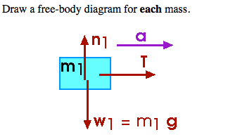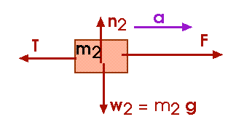
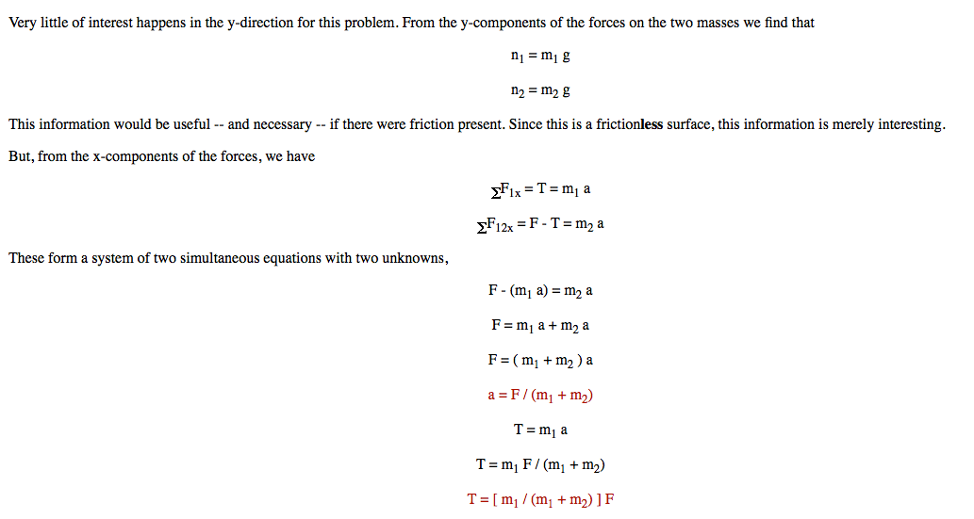
- Two blocks, joined by a string, have masses of M₁ = 6.0 kg and M₂ = 9.0 kg. They rest on a frictionless horizontal surface. A 2nd string, attached only to the 9-kg block, has horizontal force = 30 N applied to it. Both blocks accelerate.
  - Determine the acceleration of the blocks
M₂
M₁
F = 30 N
  - Find the tension in the string between the blocks.
A:
a. ΣF = (M₁ + M₂)a ΣF = (F + T) –T
set equal: F = (M₁ + M₂)a a = F/(M₁ + M₂) a = 2 m/s² right

- Choose 1 object: For M₁
ΣF = M₁a ΣF = T T = M₁a T = 12 N right

- A 5.0 kg block is placed on top of a 10.0 kg block. A horizontal force of 45 N is applied to the 10.0 kg block, and the 5.0 kg block is tied to the wall. The coefficient of kinetic friction between the moving surfaces is 0.20.
5.0 kg
10.0 kg
F = 45 N

  - Draw a free-body diagram for each block.
  - Determine the tension in the string on the 5.0 kg block.
  - Determine the acceleration of the 10.0 kg block.
A:
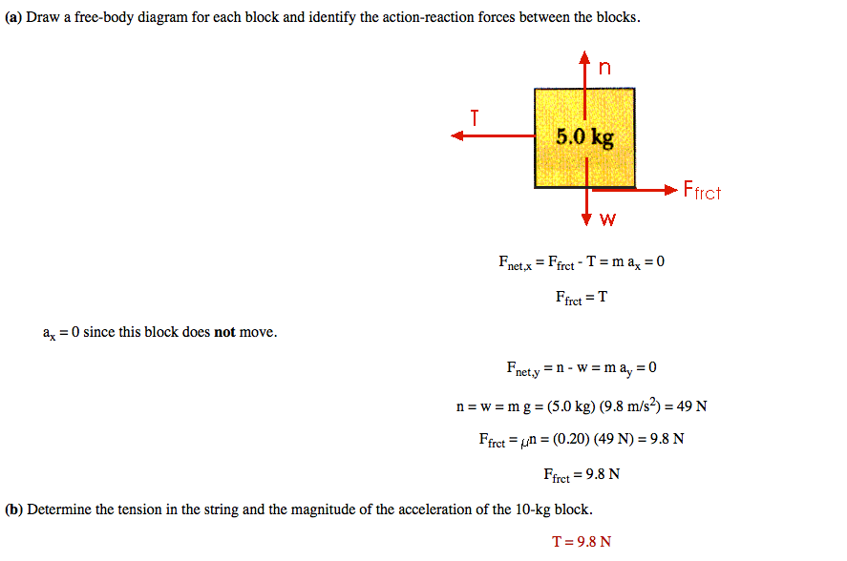
c.
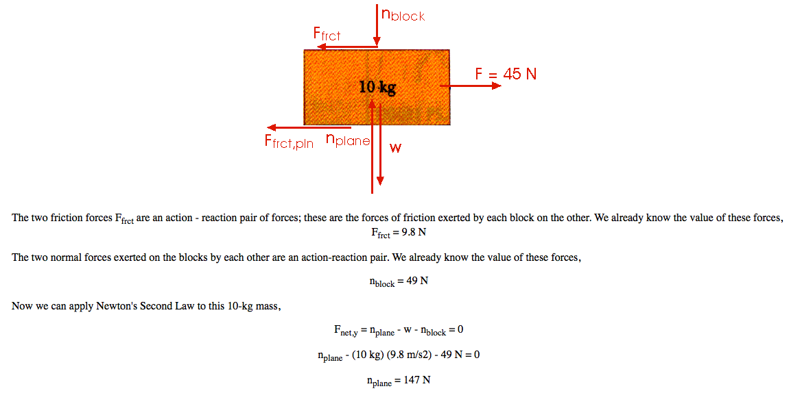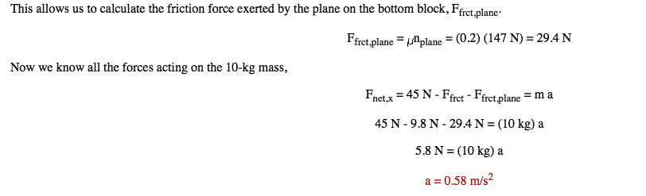
- Two blocks of mass m₁ = 5 kg and m₂ = 7 kg are placed in contact with each other on a frictionless horizontal surface. A horizontal force of 20 N is applied to the block of mass 7 kg.
  - Determine the acceleration of the two-block system.
m₂
m₁
F = 20 N
  - Determine the magnitude of the force between the blocks.
A:
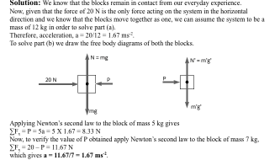

- A 75.0 kg man stands on a scale in an elevator. Starting from rest, the elevator ascends, attaining its maximum speed of 1.20 m/s in 1.00 s. It travels at a constant speed for the next 10.0 s. The elevator then undergoes a uniform acceleration in the negative y direction for 1.70 s until it comes to rest.
  - What does the scale register before the elevator starts to move?
  - What does the scale register during the first 1.00 s?
  - What does the scale register while the elevator is traveling at a constant speed?
  - What does the scale register during the time it is slowing down?

A: The scale registers the force it applies to the man, the normal force.

Additional Problems (not assigned in class)
Ex 5.11 Why can you exert greater force on the pedals of a bicycle if you pull up on the handlebars?

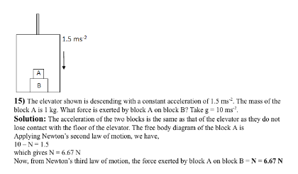

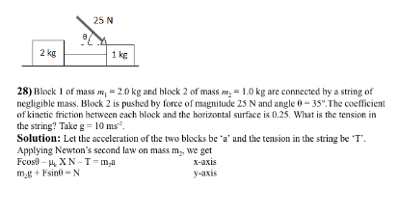

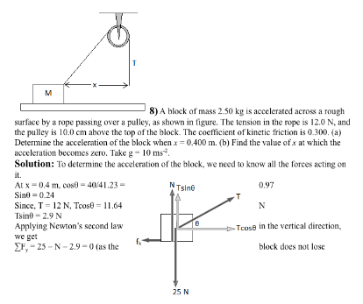
Additional Problems Answer Key:
Ex 5.11 Why can you exert greater force on the pedals of a bicycle if you pull up on the handlebars?

The handlebars then pull down on you, somewhat as if someone were pushing down on your shoulders. This lets you exert a greater downward force on the pedals

