Physics First Semester Review 17-18 Name: ____________
Impulse & Momentum: Chapter 6 (momentum, impulse, collisions)
Equations:p=mv Ft=Δp Δp = mv_{f}-mv_{i} m₁v_{i1} + m₂v_{i2} = m₁v_{f1} + m₂v_{f2} (m₁+m₂)*v_{i} = m₁v_{1f} + m₂v_{2f} m₁v_{1i} + m₂v_{2i} = (m₁+m₂)*v_{f}

Momentum/ Impulse T or F:
- If the momentum of an object changes, a force was present
- A small object can have the same momentum as a large object
- An object with more mass has more momentum than an object with less mass moving with the same velocity
- An egg dropped on the ground breaks while an egg dropped on a pillow doesn’t because the one dropped on the pillow has a smaller change in momentum
- An egg dropped on the ground breaks while an egg dropped on a pillow doesn’t because the one dropped on the pillow has a smaller impulse
- Change in momentum and impulse refer to the same quantity
- The impulse on an object involves a force during a period of time
- Momentum depends on velocity, therefore it can be a negative value
- Impulse cannot be negative because time cannot be negative

- Which has more momentum, a car or a baseball moving at the same speed? Why?

- In the bouncing dart demonstration, the bouncy side of the mallet caused the cart to move faster after collision than the dead side of the mallet. Why is this? (use conservation of momentum to explain)

- What are the three types of collisions and give an example of each?

- A glass ball, ball A, of mass 5.0 kg, moves at a velocity of 20 m/s. It collides with a second glass ball, ball B, or mass 10.0 kg, moving along the same line with a velocity of 10 m/s. After the collision, ball A is still moving, but with a velocity of 8 m/s.
  - What is ball A’s change in momentum? Ball B’s change in momentum?
  - What is the momentum of ball B after the collision? The speed of ball B?

- Show mathematically how a 2500 kg truck moving at 15 m/s can have the same momentum as a 10.0 kg tricycle moving at an unknown speed.

- Two identical eggs are thrown. One at a brick wall and the other at a sheet.
  - Which egg experiences a greater impulse? Change in momentum? Force?
  - How does the time of each collision compare to each other?

- A person stands at rest on rollerblades while holding a heavy rock. The person throws the rock forward. Explain what happens to the person on the rollerblades after throwing the rock.

- How much time does it take a 215 kg motorcycle traveling at +75 m/s to stop if a crash barrier imparts a force of -5400N on the motorcycle?

- While standing motionless on his rollerblades, a student, who has a mass of 78 kg, throws a 0.50 kg tennis ball forward. If the student moves backwards at -4.3 m/s, with what velocity was the tennis ball thrown?

- A 0.25 kg baseball moves at +14.5 m/s towards a stationary catcher, who has a mass of 88 kg. What is the final velocity of the combined catcher and ball?

- Two dodgeballs (both with a mass of 0.80 kg) collide in midair. Initially, ball A was moving at 26.7 m/s, while ball B was moving at 15.7 m/s in the opposite direction. After they collide, ball A is moving at 1.4 m/s in it original direction. What is the velocity of ball B?

- How does a gymnast’s padded mat protect the athletes? What is the reason for having a crumple zone in a car?

- An astronaut’s tether breaks, causing the astronaut to drift away from a shuttle. What should the astronaut do to return to the shuttle?

- A 44.0 kg child throws a 22.0 kg exercise ball so that he moves with a velocity of 3.50 m/s. What is the velocity of the exercise ball?
- When you land a jump, why does it hurt more if your legs are stiff with your knees locked?

- Why is it dangerous to fire a gun with a bullet that has more mass than the gun?

- A 0.150 kg baseball moving at 26.0 m/s is stopped by a catcher who exerts a force of -390. N. How long was the force exerted on the ball?

- A billiard ball traveling at 4.00 m/s has an elastic collision with a billiard ball of equal mass that was originally at rest. If the first ball is at rest after the collision, what is the speed of the second ball after the collision?

Work, Power, Energy: Chapter 5
Equations: K = 1/2mv² Ug = mgh Us = 1/2kx² W = Fd K_{i}+Ug_{i}+Us_{i}+W = K_{f}+Ug_{f}+Us_{f}
- A banana is at rest in a tree. It then falls to the ground. What happens to the U_{g} of the banana as it is falling? K?

- A 2.0 kg rock is at rest on a 15 meter tall cliff. The rock then falls. What is the U_{g} of the rock when it is at a height of 5.0 meters? K? Speed?

- What must be true about the force acting on an object in order for work to be done by that force?

- As an object decreases in height it loses potential energy. Explain how this still obeys the Law of Conservation of Energy.

- A 1.5 kg ball starts from rest, and rolls down a 2.4 m tall frictionless incline. What is the speed of the ball at the bottom of the incline (system consists of the ball)? (Draw energy bar charts)

- Write a problem that uses the following equation: K + W = 0 J

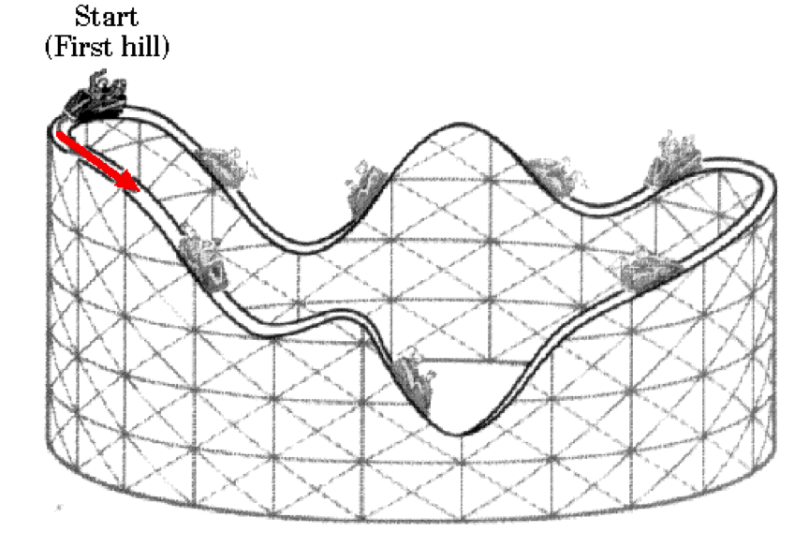
- A gymnast falls, from rest, from a height of 3.5 m. The gymnast lands on a crash mat that exerts a force of 2500 N upwards on the gymnast over a distance of 0.45 m. What is the mass of the gymnast (system consists of the gymnast)? (draw energy bar charts)

- Explain what happens to kinetic and potential energy on a roller coaster track
  - Where does the coaster have the most Ug?
  - Where does the coaster have the most kinetic energy?
  - Where does the coaster reach top speed?
  - Where does K equal Ug?

- For each energy transformation below, describe a situation in which that energy transformation would occur:
  - Ug->K
  - K-> Ug
  - W-> K

- Explain a situation in which each of the following types of work would be done:
  - + work b. - work c. 0 work

- A 250 kg polar bear moves at 1.3 m/s. At what speed must a 40. kg child move to have the same KE?

For each of the questions below, draw energy bar charts and write the conservation of energy equation:

- An 0.30 kg arrow sits motionless on a drawn back bow string. The bow string has a spring constant of 155 N/m and is stretched 1.3 m from equilibrium. The arrow is then fired horizontally. (system = bow and the arrow) What speed is the arrow going right after it leaves the bow string?

- A 2200 kg car, moving at 12.0 m/s, hits a tree. The tree applies a force on the car, which acts over a distance of 0.50 m. The car then comes to rest. What force did the tree apply to the car?

- A 1.5 kg flowerpot is moving vertically at a velocity of 2.5 m/s at a height of 22 m. What is the speed of the flowerpot as it hits the ground?

